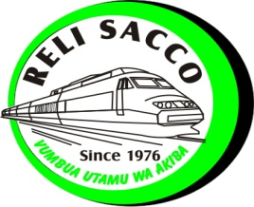

RELI REGULATED NWDT SACCO SAVINGS AND CREDIT SOCIETY LTD
Tel.0727796323/0729210867 HEAD OFFICE
info@relisacco.co.ke P.O. BOX 55541 NAIROBI

The General Manager Date: ……………

Human Resource &Admin
Kenya Railways Corporation
P. O. Box 30121

NAIROBI

Dear Sir / Madam
RE: PAYMENT OF MONTHLY SALARY – CHANGE OF PAY POINT
I …………………………………………………………………………………ID No…………………………………………………………...........
Check No.………………………….. would like my monthly Salary to be paid through KENYA COMMERCIAL BANK
AC NO. 1317456165 - ACCOUNT NAME - RELI REGULATED NWDT SACCO LTD NEXTGEN MALL BRANCH.
Effective from Date…………………………………………………………………………………………………………………………………...
Yours faithfully
Name …………………………………………..… Signature ……………………………..Check No………………………………………..
Telephone number…………………………………………………………………………………………………………………………………….

This authority is irrevocable and is to be used for deduction of Membership or Entrance Fees, Shares and Loans from my salary and can only be revoked by a the written authority from the said Society.
I consent to the pay point change till further instructions to you from Reli Regulated Sacco Ltd.

Name ………………………………………………… ID/NO. ………………………………… Signature …………………………………

For Official Use Only
Received by:-
Name………………………………………………………………… Signature ……………………………………. Date …………………
Approved by:-
Name ………………………………………………………………… Signature ……………………………………… Date………………….
CC: RELI SACCO LTD

