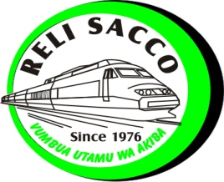
RELI SACCO SOCIETY LIMITED
P. O BOX 55541 – 00200 NAIROBI
Tel. 0727 796 323 / 0729 210 867
E-mail: info@relisacco.co.ke
HOLIDAY SAVINGS FORM
PART A: Terms and Conditions
- Interest rate to be paid shall be determined from time to time.
- The funds shall be refunded with interest at the mid of December of the current year.
- Interest shall be forfeited if withdrawal is done before December by giving a 60 (sixty) days written notice.
- Minimum contribution per month is KSH. 500 (five hundred shillings only)
- Attach a copy of your ID CARD.
PART B: Consent and Application
I………………………………………………………………….do hereby agree to save with Reli Sacco society limited and instructs Reli Sacco Society Limited and my current employer (on behalf of Reli Sacco) to recover from my salary KSH……………………. (Amount in words)…………………………………………………………………...………starting from the month of………………………………20………. till further notice.
These instructions shall remain in force unless altered by me in concurrence with the society.
My Particulars are as follows:
Employer…………………………………………………………Station……………………………………………………………………………
Check No…………………………………………………………. Employment No……………………………………………………………
Present Address…………………………………………………. Tel No…………………………………………………………………………
Members Signature……………………………………………. Date…………………………………………………………………………….
PART C: For Official Use by the Sacco
Account Application Form and I.D Verified by;
Name……………………………………………Designation……………………………Signature…………………Date…………….……
Account Opening Approved by;
Name…………………………………………. Designation……………………………. Signature…………………Date…………………
Account Opened by;
Name………………………………………. Designation………………………………. Signature………………. Date………………….

