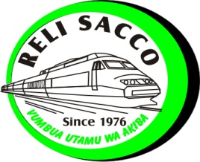
RELI CO-OPERATIVE SAVINGS AND CREDIT SOCIETY LIMITED
P.O BOX 55541- 00200 NAIROBI, KENYA
Tel. 0727 796323 / 0729 210867. Email: info@relisacco.co.ke
AUTHORIZATION TO DEDUCT FROM MY SALARY

NAME…………………………………………………………………………………………………………………………………………………
EMPLOYER…………………………………………………………………………………………………………………………………………..
DEPARTMENT…………………………………………..…………………WORK STATION………………………………………………
Employment / Check No………………………………………… Designation…………………………………………………………
Mobile No ……………………………………………………………… Date …………………………………………………………………..

Type of deduction (for loans and advances only) | Please tick where appropriate | Amount applied
Advance
Loan
Others (specify)

I………………………………………………………….I.D No………………………………………do confirm that I have taken a loan / advance with Reli sacco amounting to KSH………………………. Repayable in ……………… months. I hereby authorize my employer to make the above deductions from my salary / pension in accordance with the above terms. I understand and agree that I am responsible for the above deductions as specified in this document. This authority is irrevocable and is to be used for deduction until the amount loaned to me plus interest is fully recovered and can only be revoked by a written authority from the said society.
Given under my hand this……………………….day of…………………………20………….
Name……………………………………………………………….I.D No…………………………………Signature…………………………….
Important note to members
The above authorized deductions will be based on the AMOUNT APPROVED.

